**HW1**

**Hongkai Wang**

**Part 1: Good & Bad visualizations**

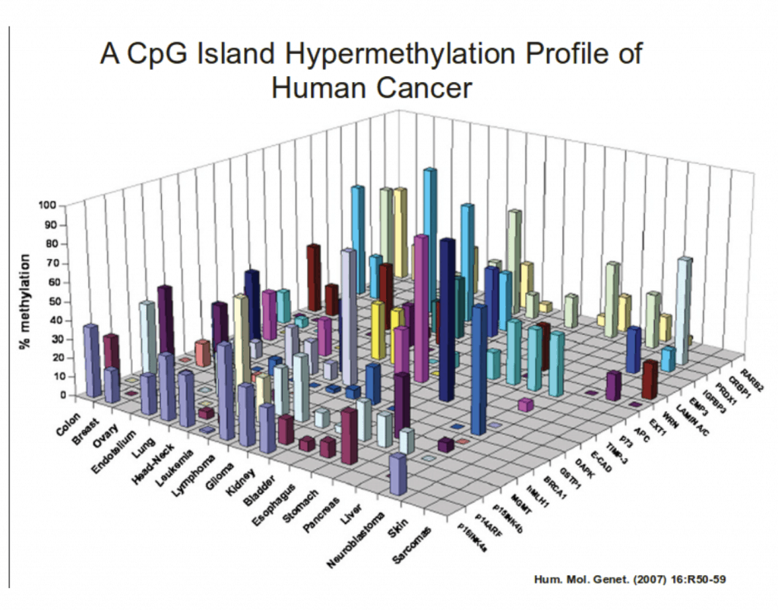The Bad:

I found this horrible graph on a blog illustrating principles of data visualization. The graph is trying to showcase methylation frequency of genes in different human organs.

URL: <https://www.oldstreetsolutions.com/good-and-bad-data-visualization>

Score: 2

Critique: Using a 3D graph is often a very bad decision. The human brain can hardly process the 3D information on a 2D media, and it often leads to misinterpretation of the information presented. In this example, the author is trying to showcase the percentage of methylation for different genes in human organs. However, It is very hard to attribute a bar to either the organ axis or the gene axis. The author tried to fix this issue by color-coding based on genes, but it is still not a perfect solution. The author would be much better off by either using a table or a heatmap to showcase the extent of the methylation. The heatmap would be especially helpful to showcase the extent of methylation with the added color element.

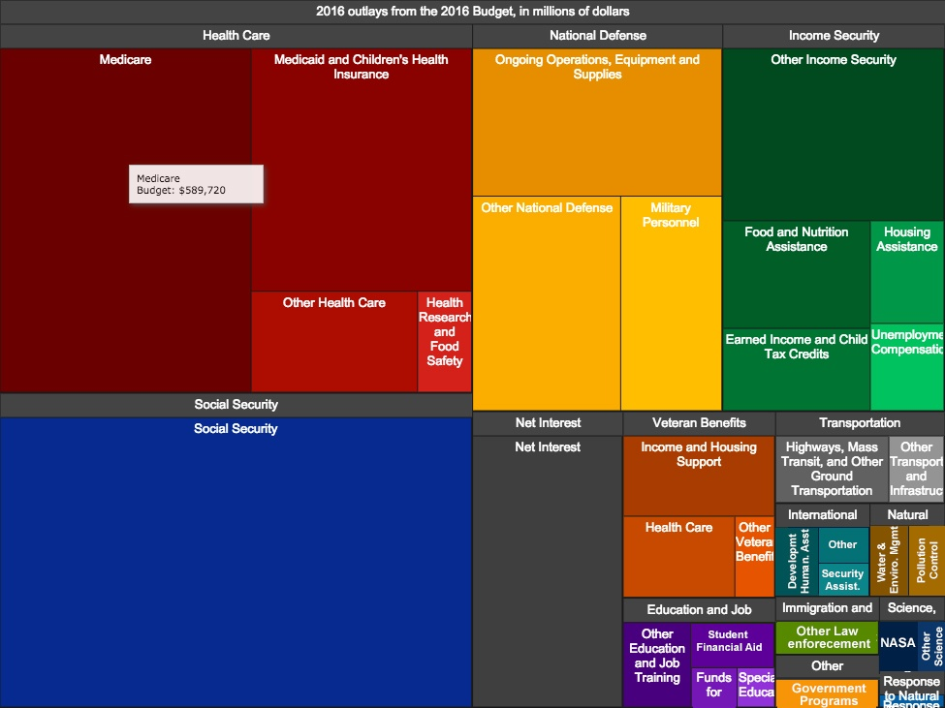The Good:

This is the 2016 US government budget breakdown graph. The graph is an interactive graph that will showcase the detailed amount dedicated to a specific area of budget for 2016.

URL: <https://www.tableau.com/learn/articles/best-beautiful-data-visualization-examples>

score:4.5

Critique: This interactive graph is simple, easy to read, and intuitively sound. The size of the blocks directly correlates to its importance in the budget while the specific amount can still be tracked down by interacting with the graph via the mouse cursor. Additionally, the color-coded categories are easy to distinguish both in-group and out-of-group.   
The grey label for each category poses a small issue for this graph. They take up some area in the square while not having a color assigned to it. This means that the overall rectangle doesn’t represent 100% of the graph, which could be an issue for some. The grey labels could be moved to outside of the graph as legends (also color coded) to combat this issue.

**Part 2: Exploratory vs Explanatory Visualizations**

1. [You Draw It: How Family Income Predicts Children’s College Chances](https://www.nytimes.com/interactive/2015/05/28/upshot/you-draw-it-how-family-income-affects-childrens-college-chances.html?_r=0&pagewanted=all)

* This is an explanatory visualization despite its unconventional approach. The author clearly knows the truth on the topic, and they are trying to discuss it with the readers.
* The graph is trying to showcase the reality on higher education and family income and challenge the existing conception around the topic.
* Now I know that the relationship between higher education and family income is highly linear and my previous view on this topic is somewhat different from the reality.
* The likely audience is for people from a more privileged background as it is published on NYT.
* The main point is to challenge existing knowledge on the topic and introduce the latest finding in new research.

1. [An Interactive Visualization of Every Line in Hamilton](https://pudding.cool/2017/03/hamilton/)

* This is an exploratory visualization. There is not a central theme to the entire project aside from the fact that all data is from the Hamilton musical. These visualizations are presented as cool facts about the show.
* The author was trying to find out the distribution/attribution of the lyrics grouped under various themes. The author grouped lyrics/lines based on actor, themes, and even musicality.
* I now know a lot about what the lines in the musicals are really about, maybe even a bit too much. There is some really cool new information in the thematic section that I didn’t know before.
* This is clearly intended for enthusiasts of the Hamilton musical.
* The point is to show some cool facts about the musical itself. The project appears to be very lighthearted and is not keen on talking about some esoteric message.

1. [Bussed out - How America moves its homeless](https://www.theguardian.com/us-news/ng-interactive/2017/dec/20/bussed-out-america-moves-homeless-people-country-study)

* This is an explanatory visualization as the author is trying to tell a story on the homeless population using data.
* The authors attempted to find out what exactly happens to the homeless people who took a one-way bus out of town.
* I now know where the homeless people went (state and institutions) after the bus ride and the general trend for homeless immigration through buses.
* This is intended for any people interested in the livelihood of the homeless population. But judging from the scale of the article, this is also intended for people who received adequate education.
* This article/visualization is looking to elicit empathy for the homeless people and call for better treatment of the group by telling the story on these people through the one-way bus story.